1. Which one of the following representations is proper for the knapsack problem?

R: Binary

Justification:

* We need 2 values in order to decide if an object is taken into account or not (is put in the knapsack) 0 - NO, 1 – YES, so we will illustrate decisions by using the binary representation

1. Which one of the following representations is NOT proper for the N-QUEEN problem?

R: Binary

Justification:

* The position of the queens must be unique, so we need to illustrate them by using different values in a vector with integers, that either contains only the information from rows, or from columns only (0 and 1 would not be enough, suggestive)

1. What is the fitness function for the KNAPSACK PROBLEM?

R: The number of objects placed inside.

1. What is the fitness function for the N-QUEEN PROBLEM?

R: The number of queens that attack each other.

1. Consider the following rule for a RBS in an uncertain environment: *If the father is old and the mother is young the child has a chance to live longer.*

What is the proper logic operator used between the fuzzy variables when we apply this rule?

R: AND

1. Enumerate the elements that determine the probability for a new possible element to be added to the solution in an ant colony system

R: - Pheromone trail + higher pheromone value => intensity

- Higher visibility of further nodes

- Trail importance coefficient

- Visibility importance coefficient

1. On what is based the ant colony system?

R: The pheromone trace left by ants

1. What are the main specific features of a particle in PSO optimisation?

R: Current position and velocity

Fitness

1. What is a proper encoding for an individual in Genetic Programming?

R: A computer program that solve the given problem

1. Which of the following problems **can’t** be solved by a perceptron?

R: XOR

1. How is propagated the error into an artificial neuronal network who uses it as learning the backpropagation algorithm?

R: It propagates backwards

1. Using an ANN we want to determine if a shape from a black and white image is a circle or not. The image has 10x10 pixels and the ANN has the structure of 101:15:10:2 with a sigmoid activation function. What is the problem’s type?

R: This is a classification problem.

++ How many weights will have the last neuron from the last layer?

R: 10 weigths for one neuron from the output layer +

The value of the error function and the learning rate

1. Specify the correct statement(s) in a rule based system in a certain environments inference engine with Forward chaining

R:

* The inference engine allows to draw new conclusions
* Facts are represented in a working memory which is continually updated
* The actions usually involve adding or deleting items from the working memory.
* The rules are of the form: left hand side (LHS) ⇒ right hand side (RHS)
* Rules represent possible actions to take when specified conditions hold on items in the working memory.
* The conditions are usually patterns that must match items in the working memory

1. What will depend on the adjusting value of the weights if we use a backpropagation algorithm to train the network?

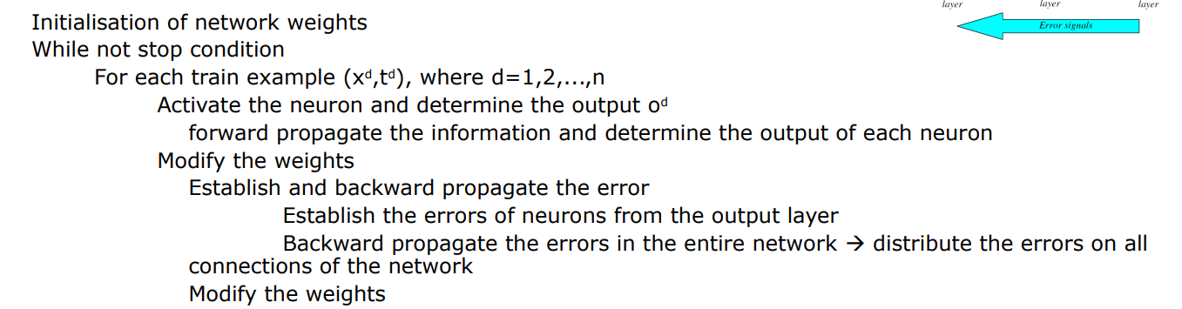

1. Consider an evolutionary algorithm that is used for searching the minimum of a real function that has a crossover operator

*offspring = parent1 + a(parent2 - parent1),* with a in [0, 2].

Describe a possible pitfall if we use this crossover:

R: If alpha is 0 offspring = parent1 + 0 or alpha is 1 offsrping = ~~parent1~~ + parent2- ~~parent1, i~~t means that the population is not changed, so we don’t have evolution.

1. For a Genetic Programming algorithm identify the correct statement(s):

R: The solution’s quality depends on the precision of variables involved in the algorithm.

1. Fuzzify the raw input data for a person of 45 years old.

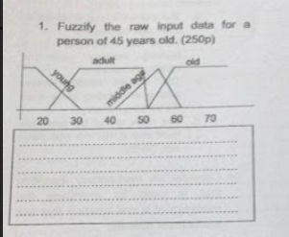

1. Enumerate 4 crossover operators (with a short description) for real representation used in Evolutionary Algorithm

R:

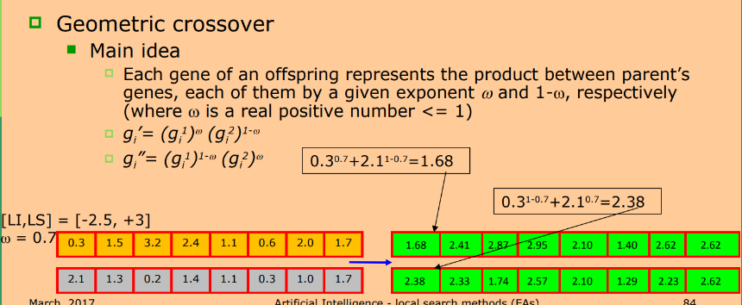

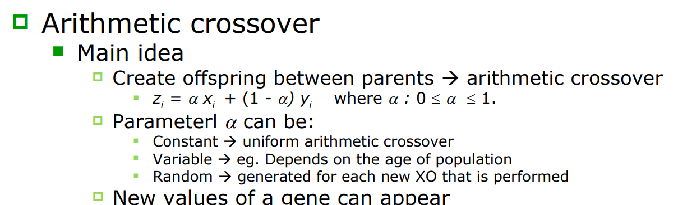

1. For the following problem describe (NOT CODE) a solving method using evolutionary computation (representation, computation, fitness, selection)

**There is a set of cards printed with integer numbers. Select a subset in such way that the sum of the numbers engraved on them should be M (or as close to M as possible).**

**REPRESENTATION**

Because it is given that we have a SET of cards, we will consider that each card is unique. So our problem will be similar to the Knapsack one.

In this case, the representation will be a binary one. We will have for the Genotype bit-strings, which will tell us (as a PHENOTYPE) if a card is selected for the subset or not (0 for NO and 1 for YES).

**COMPUTATION**

**Mutation & Crossover**

**FITNESS**

I consider that a good a fitness function would be abs(M – sum of the selected cards), where M is the total sum of cards in the subset (MINIMIZATION)

**SELECTION**

* Recombination:

Ranking selection – sort population based on fitness – individuals have ranks

Best individual rank miu and the worst one rank 1

* Survival:

Elitism - Keep the best individuals from a generation to the next one (if the offspring are weaker than parents, then keep the parents)

1. Enumerate 4 selection methods (with a short description) used by Evolutionary Algorithm

